Fluid Mechanics

1. Fluid static
   1. Pressure & Pascal’s law (Momentum conservation)
      1. Gage pressure:
      2. Pascal’s law, AKA hydrostatic equation, is used in quiescent fluid.
         1. Extended Pascal’s law
      3. Pressure trapezoid
      4. Moment (Torque)
   2. Mass conservation
2. Energy Equation (Bernoulli’s Equation)

   2. Head loss factor
      1. Curved streamlines, AKA ‘Minor losses’

* + 1. Straight streamlines , AKA ‘Major losses’, using Moody diagram to find out head loss factor,

1. Non-dimensional Analysis: Buckingham Pi Theorem

如果没有无量纲分析，，制作出来的工程表将会是T分别关于四个变量的关系，也就是说，控制变量实验每次都只能改变一个变量以得到其余三个变量对应变量的关系，那将会要求大量的实验以满足大量的数据要求，最终消耗大量的人力物力，制出的表的体量也将会十分巨大。

以举例，运用无量纲分析，最后是与之间的一个关系，并且更多的未实验数据可以通过外推(Extrapolation)&内推(Interpolation)来得到。最后的结果仅为与两项。在使用来计算或者vice versa, 只要计算一组再查表得到另外一组即可。

1. External Flow (normally 0.01m<L<10m)
   1. Drag & Lift
      1. SPAGT Equation (Force balance) & Navier-Stokes Equation
         1. SPAGT Equation 图片包含 文字

            描述已自动生成
            1. Shear force (due to viscous eff) ，与物体表面相切，固体和流体之间的相互作用（库仑力），通过黏度来表达（物体的分子会因为黏度而转移到另一端）。
            2. Pressure force:垂直于物体表面，分子撞击表面而产生（库仑力的相互作用）
            3. Thrust
            4. Anchoring Force(锚固力)，如果Control Volume 包含了固体和流体，则会产生锚固力
         2. Navier-Stokes Equation(微分形式)

其为SPAGT的微分形式

* + 1. BGLAD Equation: , BLD are found by dimensional analysis & lab model.图片包含 文字

       描述已自动生成
       1. Transformation: Pressure in SPAGT can be broken into 3 parts: Buoyancy, Lift & Drag
       2. Buoyancy:
       3. Drag:(similar with friction, friction恒定不变，drag变化 ) 和V方向相同 , Provided by the turbulence in wake region
          1. Viscous drag
          2. Pressure drag
       4. Lift: 必须要有流体承载，和flow rate方向垂直
       5. SPAGT or BGLAD, which one is better to choose?
  1. Boundary Layer
     1. Definition: A thin region on the surface of a body in which viscous effects are very important & outside of which the fluid behaves essentially as if it were inviscid.

1. Open channel flow图片包含 文字, 地图

   描述已自动生成
   1. Manning’s equation: ,
   2. Energy
      1. Difference between pipes & open channel flow(river): pipe adjusts head loss by changing pressure, but putting on KE or PE, so there is no pressure head in the energy equation, because the pressure in open channel flow cannot bigger than (hydrostatic), if so, the fluid surface will be unstatble.
      2. Specific Energy (SE)
      3. EGL Energy Grade Level
      4. HGL Hydraulic Grade Level
      5. 在大间隔的情况下，通过降低KE来降低SE或者降低PE来降低SE都不可行，只有在极小的间隔下才能成功，因此需要Specific Energy Diagram
   3. Hydraulic jump图片包含 屏幕截图

      描述已自动生成
      1. 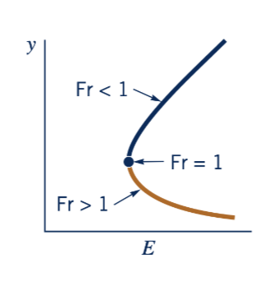If Fr#<1, use supercritical, otherwise use subcritical
      2. Engineers force a critical point by building a weir (a blockage) & then use at critical point to measure V 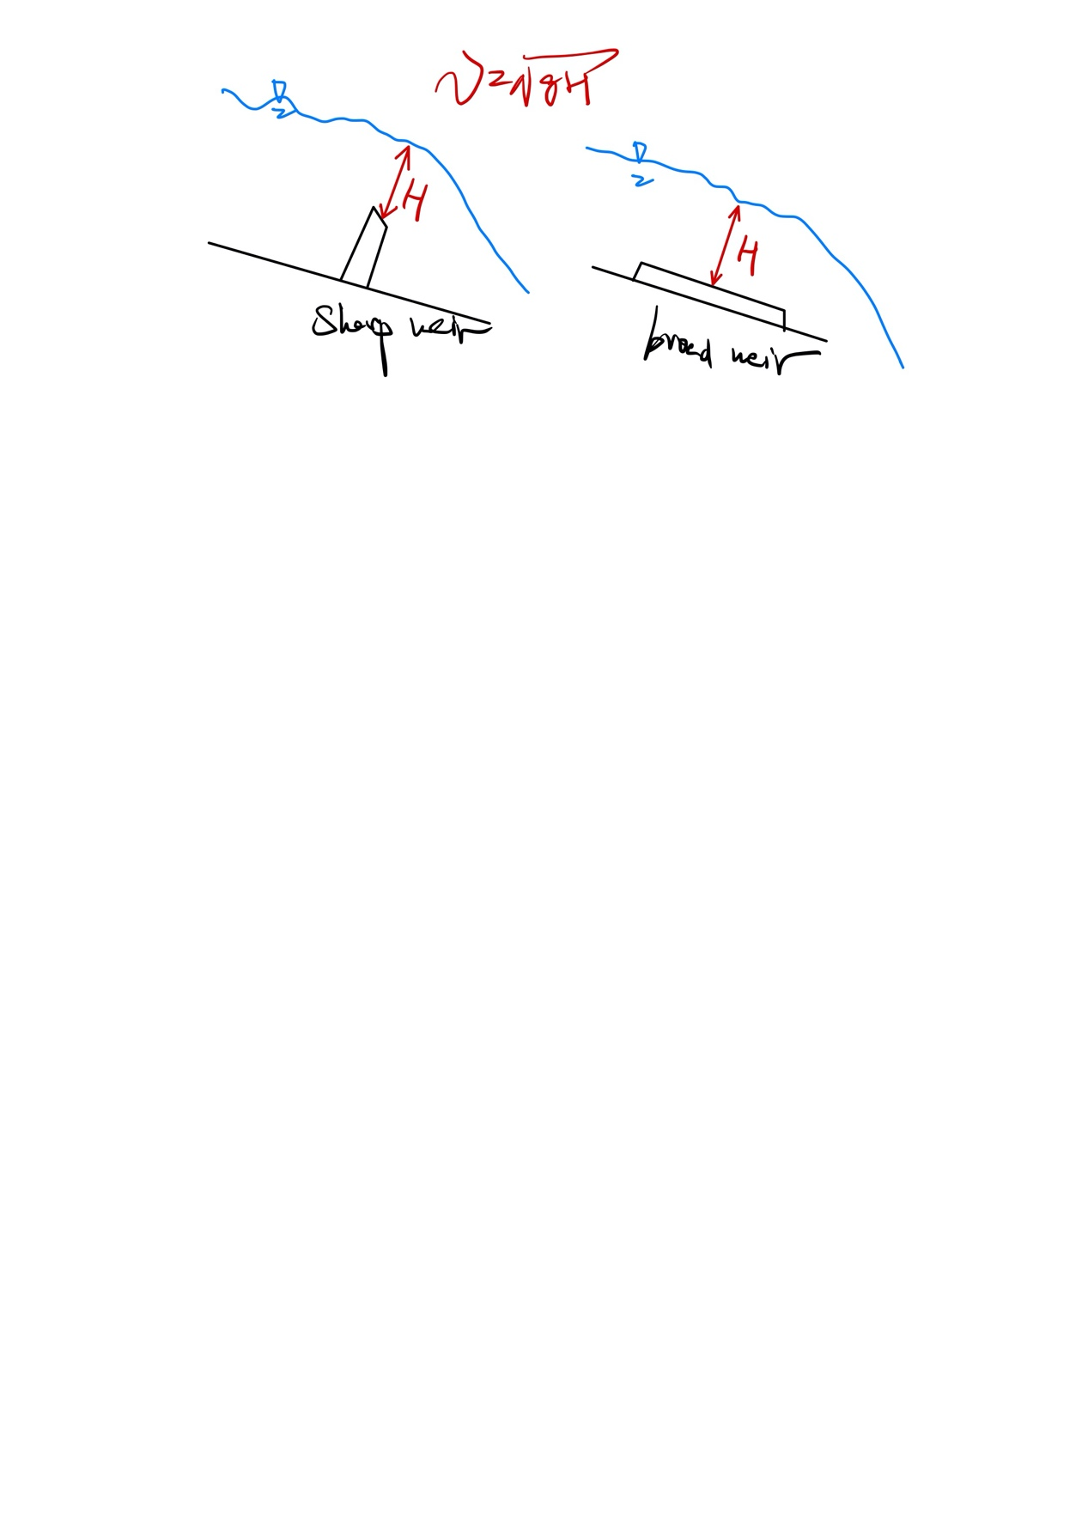
2. CFD (Computational Fluid Dynamics) 计算流体力学